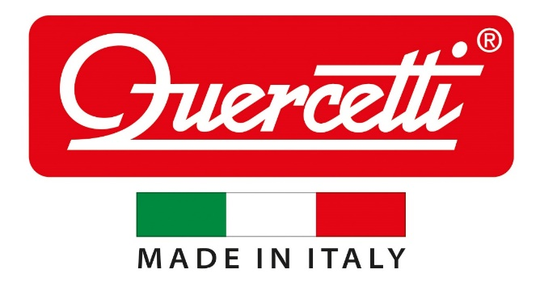

Best Sellers

#04180 Quack & Flap
#00242 Daisy Shape Sorter
#06499 Spiral Tower Brightball
#06506 Migoga Junior
#00230 Smart Puzzle
#04190 Fantacolor Junior
#02935 Magnetic Best Friends
#04170 Saxoflute
#02341 Kaleido Gears
#05321 Double Sided Mag Board
#01805 Peg Brite
#06546 Migoga Transparent Run

